# Experimental Report

## CP1N2-24721015 李鹏麒

# **所属内容：Experimental N2-C1-20241012**

# **完成部分说明：编写算法与代码、调试与测试、撰写实验报告**

**The programme language**: C language

**The programming platform**: Visual Studio 2022

**Program function**:

(1)Calculating the Celsius temperature corresponding to the Fahrenheit temperature of 100F.

(2)Guessing positive integer values less than 500.

(3)Verifying the value range of variables with integer type.

**Program algorithm**:(Specific code is in the folder)

(1) The calculation formula of two temperature conversion is as follows :

Celsius temperature c =5*( f-32)/9

Fahrenheit temperature f =( c*9/5)+32

Then it can be calculated directly.

1. Firstly, enter a positive integer value and store the value in the integer variable a. Then, enter the positive integer value of the guess and store the value in the integer variable b. Both of them using the function scanf() (especially, scanf_s() in the Visual Studio). Finally, using while and if else statements to judge whether the guess is correct. Use the judgment statement of the cycle to define(Correct == 0) , enter the loop when the guess is wrong, and jump out of the loop when the guess is correct(Correct = 1).
2. Determine the data type of the language standard and its boundary value first. Then, defining a variable of integer type whose initial value is assigned to the given boundary value(using while(1) to find it). Finally, performing arithmetic operation on the defined variables(maximum+1 and minimum-1 for that exceeding the maximum will turn to be minus and below the minimum will turn to be plus) and detect the operation results(using if) , so as to verify the value range of integer type variables

**Program flow chart:**

(1)Calculating the Celsius temperature corresponding to the Fahrenheit temperature of 100F.

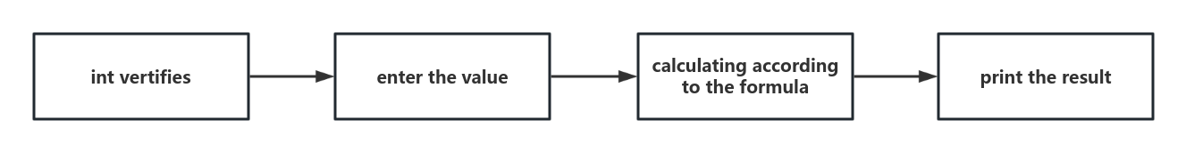

1. 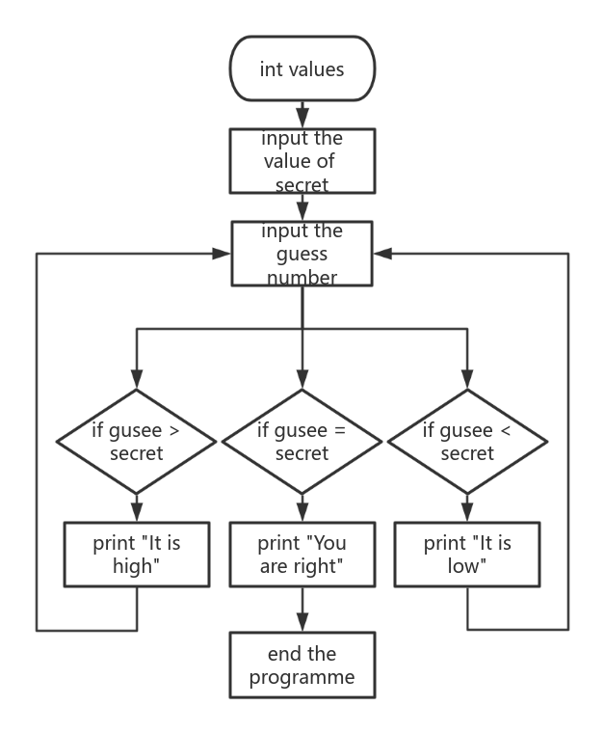Guessing positive integer values less than 500.

(3)Verifying the value range of variables with integer type.

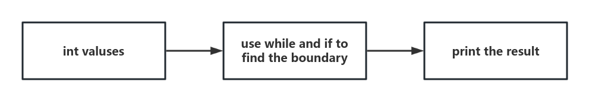

**Program experiment test:**

(1)The test has noticed the retention of the output decimal place.

1. After testing, the definition of the judgment condition and the use details of braces and semicolons are found. The life interval of the program is important.
2. After many experiments, we find the boundary and find the changes beyond the boundary.